SITE SURVEY REPORT

WORLD MOBILE SITES SURVEY_ZANZIBAR

Site name: | Jang’ombe Special ICT School
Site address:
Date: | 23/11/2021
Participants: | Name | Signature
SSW Engineer | Emmanuel Edward

Contents
SITE SURVEY REPORT 1
WORLD MOBILE SITES SURVEY_ZANZIBAR 1
1. GENERAL INFORMATION 3
1.1 Site Info: 3
2. SITE INFRASTRUCTURE 4
2.1 Pole Installation: 4
: 4
2.2 Solar Power System 4
2.3 Antenna system info: 5
3. SITE PHOTOS - SKETCH OF THE SITE LOCATION, POLE LOCATION AND THE REQUIRED ANTENNA ATTACHMENTS 5
3.1 Site Physical location: 5
3.2 The Pole and Solar panel location: 6
4. REQUIRED QUANTITIES OF INSTALLATION MATERIAL 7
5. POTENTIAL CHALLENGES 8
6. REGULATORY COMPLIANCE CHECKS 9
7. RECOMMENDATIONS 9
8. SURVEYOR REVIEWER INFROMATION 9
APPENDIX 11

1. GENERAL INFORMATION

1.1 Site Info:

Site location and GPS Coordinates | Site is located at Benjamin Mkapa Road, Stone town.  Long:
Site location and GPS Coordinates | Latitude: -6.10’31’’  Long:39.11’15’’ | Longitude: 39.12’22’’ |  | Altitude:
Site Type and Ownership | Type: Secondary School |  | Owner’s name: Government/Public owned
Contact person for Site details: | Name: |  | Telephone:
Is a special permit required for site access? | Yes  The head of school should be notified prior to accessing the site |  | No ☐
Site access time: | 7x24  | 5x8 ☐ |  | Other (state):
Ease of vehicular access:  (day X hours) | Normal  | Difficult ☐ |  | Very Difficult ☐
Ease of vehicular access:  (day X hours) | Hard-standing☐ | Gravel ☐ |  | To be constructed☐
Route instructions (if required):
Describe the Site/Service Area: | The school is located along the Jang’ombe Road about 200m from the road  The site is located in the residential area and surrounded with tall trees  Moreover there is a Jangómbe primary and secondary school nearby the site
Potential Beneficiaries | - Occupants of the school  - Jang’ombe primary and Secondary School  - Members of the community and business personnel
Comments: | The site is accessible on all days with prior notice to the school with the exception of special occasions such as the National examinations

2. SITE INFRASTRUCTURE

2.1 Pole Installation:

:
Required Infrastructure: | POLE INSTALLATION
Pole Location | Pole will be positioned on the ground
Pole Location | Latitude: -6.10.32” | Longitude: 39.12’23’’ | Altitude: 60.7m
Pole type (recommend required height) | Counter weight ☐ | Wall mounted ☐ | Other  Ground based  H=6m
Describe if foundations is needed/rooftop/ground based | Foundation is required
Describe Roof/Mounting surface conditions | This is shown in the photos at section 3
Comments:

2.2 Solar Power System

Required Infrastructure: | SOLAR POWER SYSTEM INSTALLATION
Solar power system Panel Location | Panel location: Ground based | The solar panels will be located along the pole location
Solar Panel coordinates | Latitude: -6° 9’ 32’’ | Longitude: 39°12’ 23’’ | Altitude: 60.7m
Solar panel mounting | Position: Ground | Type: Metallic mounting required.
Battery and Controller location | Server room
Comments:

2.3 Antenna system info:
Antenna/Access Point:
Antenna model / height:
Coverage | AP to provide coverage to the school and nearby government offices , hotels and other business nearby
Antenna Mounting  (Type and height of the pole | 6 meters pole, Ground based pole
Availability/Location of backhaul fiber and connectivity options | Fiber connectivity is recommended
Comments | AP that supports:  - Dual bands i.e. 2.4GHz and 5GHz.  - MU-MIMO technology and at least 802.11ac for 5GHZ and 802.11n for 2.4GHz is recommended.

3. SITE PHOTOS - SKETCH OF THE SITE LOCATION, POLE LOCATION AND THE REQUIRED ANTENNA ATTACHMENTS

3.1 Site Physical location:

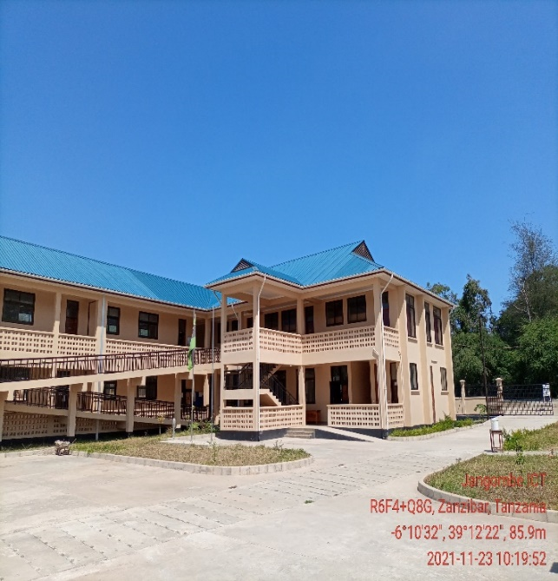 | 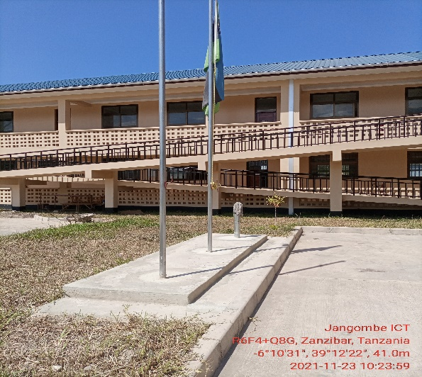

3.2 The Pole and Solar panel location:

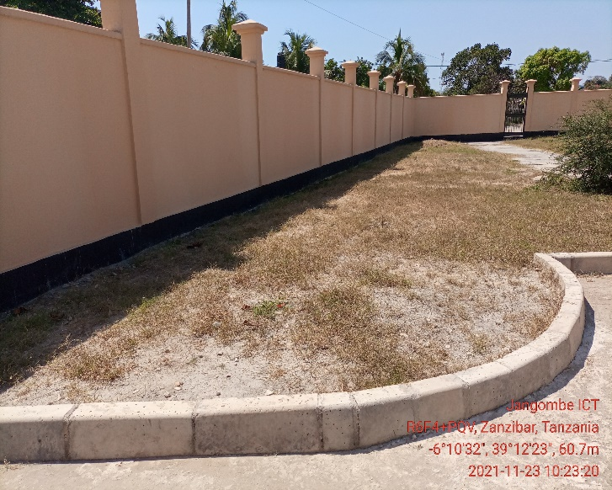

4. REQUIRED QUANTITIES OF INSTALLATION MATERIAL

S/N | Material/Equipment | Specifications | Unit | Quantity
1 | Pole | 1 Counter weight type. | Meters | 1
2 | Mounting type (Antenna) | Counter weight support
3 | Cables | CAT 6 Outdoor | Meters
4 | POE |  | PC | 1
5 | Extension cable |  | PC | 1
6 | Connector | RJ45 | PCS | 2
7 | Socket outlet |  |  | 1
8 | Plug |  |  | 1
9 | DC cable red | 16 sqmm | Meters | 6
10 | DC cable blue | 16 sqmm | Meters | 6
11 | PVC conduit pipe | 1 inch | PCS | 15
12 | PVC elbow | PVC, 1inch | PCS | 6
13 | Cable tie |  | pkt | 4
14 | U Clamp | 1inch | PCS | 15
17 | Iron bar | 8mm | PCS | 1
18 | Earth cable | 16sqmm | Meters | 30
19 | Earth rod | 2ft | PCS | 2
20 | Raw bolts | 4mm | PCS | 8
21 | Extension cable | Tronics | pcs | 1
22 | Flexible cable | 2.5sqmm,3core | Meters | 40
23 | Flexible conduit | 1inch | Meters | 6
24 | Insulation tapes | red and black | Pcs | 2
25 | Cable rugs | 16 sqmm | PCS | 8
26 | Cement | Bags | Kg | 50
27 | Sand | Bags | Bags | 4

5. POTENTIAL CHALLENGES

Challenges | Description
- Any restrictions on time we can work?  - Any access issues?  - Detail any challenges caused by existing site architecture?  - Will the installation annoy or adversely affect neighbors / be vulnerable to theft or damage?  - Are there any additional permissions to work on site required?  - Describe any security challenges  - Any other challenges? | Company IDs will be required for access,  nil  The site has 24hrs security protection and is wall fenced  Nil.  The building is under renovation

6. REGULATORY COMPLIANCE CHECKS

PERMIT REQUIRED | STATUS (Obtained/Not Obtained/In progress/ In progress)
TCRA
Municipal Authority
Land lord
Engineer checks e.g. Structural
Integrity test

Any other certification/Permit
Comment | Pole foundation construction and other civil works, will require authorization  Note: World Mobile is responsible for acquisition of all permits  Since there are government offices a consideration during instalment should be consider

7. RECOMMENDATIONS

 | Check the appropriate box below
- Approve site for system installation
- Do not approve site for system installation (If not approved specify reasons for rejections)
Comments | There is a university campus nearby about 300 m. This justifies the business case which aims to provide coverage to more than the people in the site location

8. SURVEYOR REVIEWER INFROMATION

Name:
Organization
Signature Date:
Please list other committee members in reviewing this design
Name:
Organization
Signature Date:

APPENDIX

